Acceptance Test:

User friendly GUI for bioinformatics tools.

Test Criteria:

When the user runs the program an informative and visually appealing GUI appears on the window.

User can now see various buttons along with short description of their function.

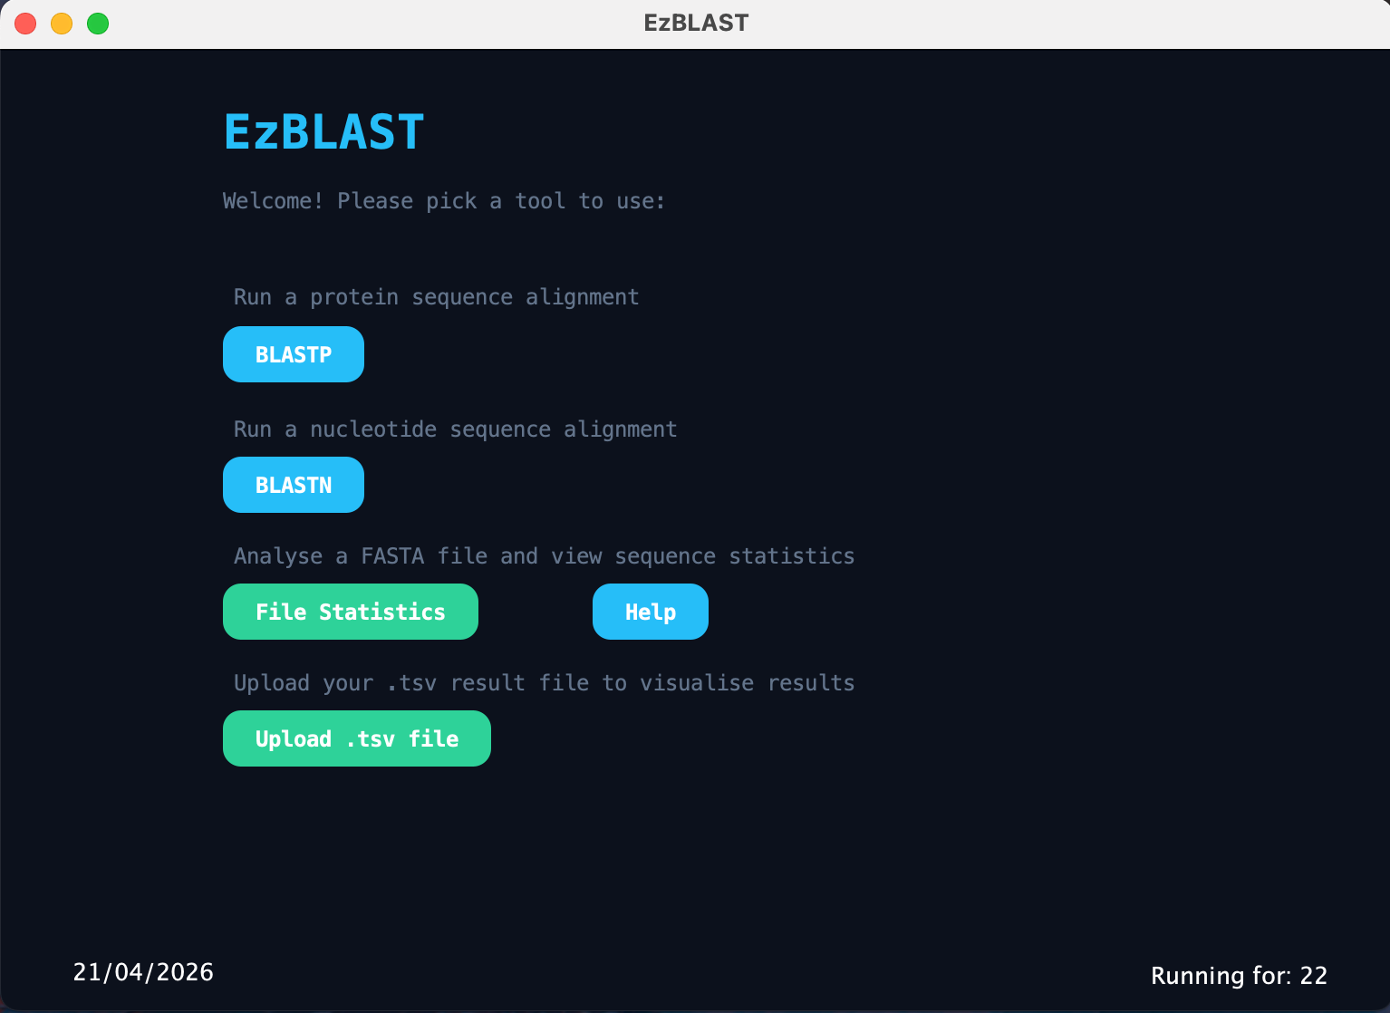

Instead of a separate “Help” button a descriptive label was added above the buttons. File statistics functionality needs more explanation hence a dedicated “Help” button was assigned to it.

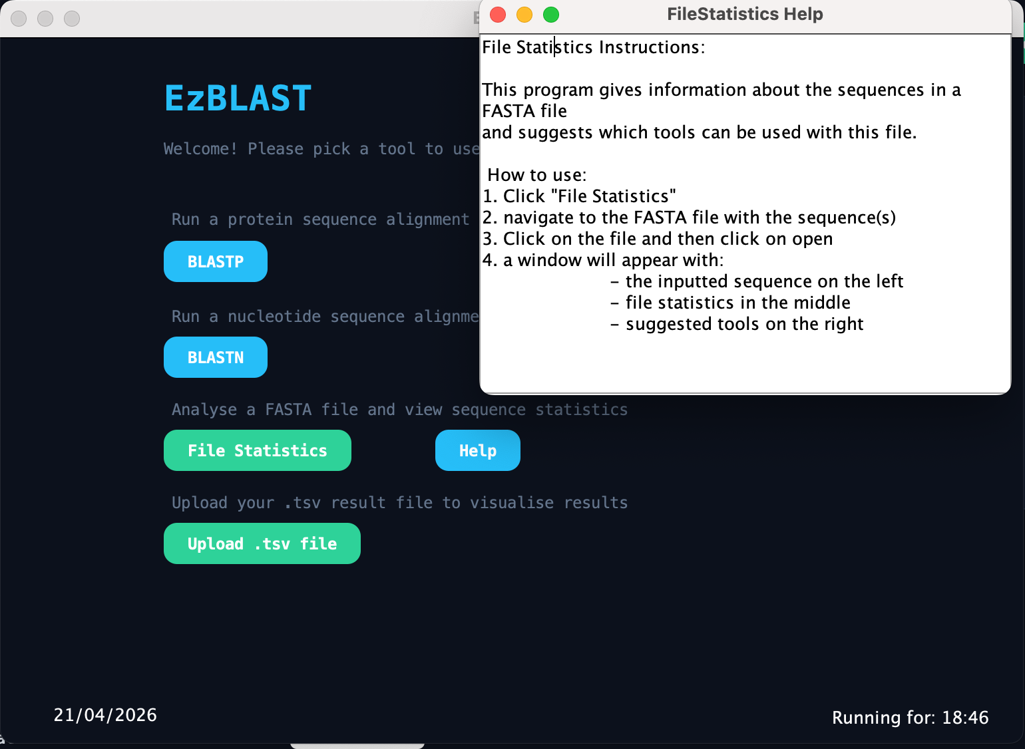

When the user clicks on BLASTP button a new GUI opens and there is a dedicated Help button for the BLASTP GUI.

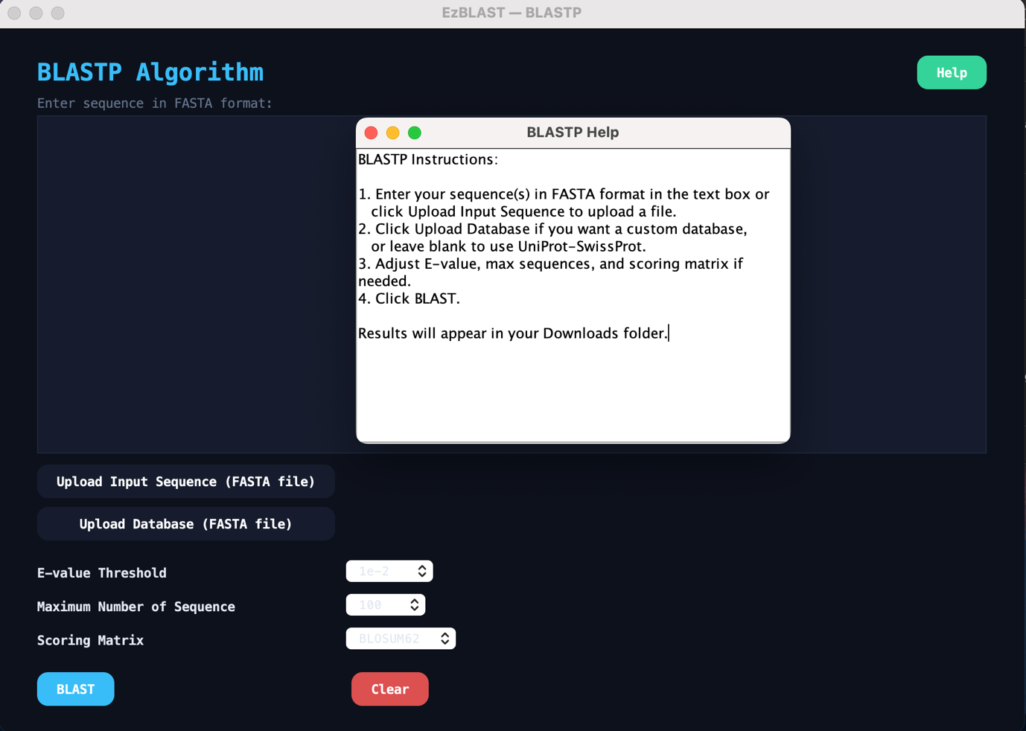

When the user clicks on BLASTN button a new GUI opens and there is a dedicated Help button for the BLASTN GUI.

